Service Principal Name PowerShell Module - Installation and troubleshooting guide

# SPN PowerShell modules contains a number of functions to manage SPNs (ServicePrincipalName). The module contains three functions: Get-SPN: List SPNs in a Service Account Add-SPN: Adds new SPNs to a Service Account Remove-SPN: Removes SPNs from a Service Account

# Functionalities / Features

The module has the following features:

* **Get-SPN function**
  1. List Service Principal Names in multiple Service Accounts
  2. Option to specify Credential or not; also option to specify a Domain Controller name.
  3. Writes information on screen to inform you of task being performed.
  4. Checks that the Service accounts exist before executing the command.
* **Add-SPN function**
  1. Checks that the Service accounts exist before executing the command.
  2. Check whether the SPN is already registered in the Service Account before attempting to add it.
* **Remove-SPN function**
  1. Checks that the Service accounts exist before executing the command.
  2. Check whether the SPN is already registered in the Service Account before attempting to remove it.

# Installation

To install Service Principal Name PowerShell Module:

* Download the zip file SPNModule.zip and unzip and copy the SPN folder to “C:\Users\<username>\Documents\WindowsPowerShell\Modules”
* Open a PowerShell Console and run the command : Import-Module SPN
* To get help, type the command:

Get-Help Get-SPN -Detailed or

Get-Help Add-SPN -Detailed or

Get-Help Add-SPN –Detailed

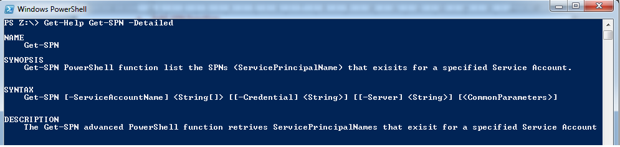

* To get full help information, type:

Get-Help Get-SPN -Full or

Get-Help Add-SPN -Full or

Get-Help Add-SPN -Full

# Examples

To get all SPNs registered in the service account called SPN_Example:

Get-SPN -ServiceAccountName SPN_Example -Credential domain\domain_account -Server ADServer_name

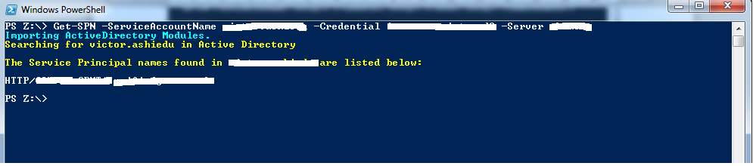

To add an SPN called HTTP/test.domain.co.uk to a service account with samaccountname User.Example, run the command below:

Add-SPN -ServiceAccountName User.Example -SPNs HTTP/test.domain.co.uk -Credential domain\user_name -Server ADServer_Nam

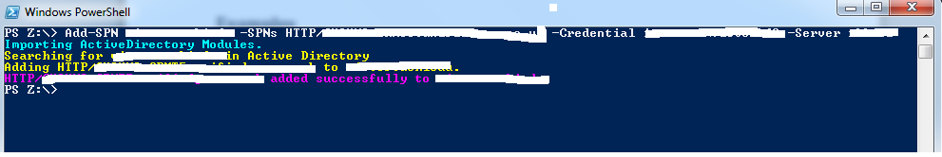

To remove an SPN called HTTP/test.domain.co.uk to a service account with samaccountname User.Example, run the command below:

Remove-SPN -ServiceAccountName User.Example -SPNs HTTP/test.domain.co.uk -Credential domain\user_name -Server ADServer_Nam